Title: Patient’s Attitude and Knowledge towards the Usage of Barrier Technique by Orthodontists.
Type of Manuscript: Original Research
Authors:
Dr. Tarulatha R Shyagali.
Dr. Deepak. P. Bhayya
Work attributed to: Department of orthodontics and dentofacial orthopedics
Darshan dental college and hospital,
Loyara, Udaipur.
Corresponding Author:
Dr. Tarulatha R Shyagali MDS
Staff qutraus no:6Darshan dental college and hospital campus,
Loyara, Udaipur.
E mail ID : drdeepu20@yahoo.com , drdeepu20@rediff.com
Mobile No: +919-9928413378, +919-9929149217
Fax No: 0294-2452273
Running Title: Attitude and Knowledge towards the Usage of Barrier Technique
Abstract:
The article aimed to assess the patient’s attitude and knowledge towards the use of barrier technique by the orthodontists. One hundred orthodontic patients of age 15-20 years, who visited the department of orthodontics, Darshan dental college, Udaipur, were randomly selected and asked to fill the questionnaire of ten questions related to the usage of barrier technique by the orthodontists. The collected data was subjected to descriptive statistical analysis and chi-square tested was performed to evaluate the difference between the genders. Ninety six percent of patients felt orthodontist should wear gloves and 98% wanted their orthodontist to wear mouth mask, 74% of patients thought that both orthodontist and the patients will be protected from the spread of the infection and 58% of them also wanted orthodontist to wear protective glasses during the treatment procedure. Eighty eight percent of them refused the treatment by orthodontists who were not wearing the gloves and 75% wanted the gloves to be changed for each patient. Significant difference was seen between females and males for the attitude towards the barrier technique used by the orthodontist. High level of awareness is seen in the present group of orthodontic patients and this warns the orthodontic to review their infection control strategies.
Key words: Gloves, Orthodontist, Attitude, Infection.

Introduction:
Every patient has the right to receive the best care and treatment whenever he/she comes to hospital regardless of his or her health status at the time of hospital visit. Wide spread increase in the contagious diseases like HIV, hepatitis, H1N1 (swine flu), cytomegalo virus and herpes simplex, pose an increased risk of cross contamination to the orthodontists, the risk is not only pertinent to them and the patient, but to their immediate family and the friends.
Wearing of gloves is one of the measures to overcome the contamination and it’s been advocated by many authorities and the authors as well ¹⁻⁵. The glove wearing not only assures the patients regarding the cross infection awareness of the dentist; it also reduces the risk of cross infection from patient to the dentist and from patient to patient ⁶. It’s also been reported that the finger nails are the potential contamination site owing to the difficulty in removing the contaminated material from the hands, particularly subungual and nail fold area^{7, 8}. Other method of protection is wearing of mouth mask, which once again may become the source of infection, if worn for long time ⁹.
In the earlier articles on infection control it has been mentioned that Orthodontist along with the general dentist avoid wearing gloves for reasons like, operating difficulties, reduce sensation, low risk of infection, skin reaction etc, ¹⁰ but this might not be applicable in present era as both dentist and orthodontist are more aware of the infection protocols. Some authors have considered that cross infection regime for orthodontist need not be as rigorous as those required in general dental practice ^{11, 12}, which is also a questionable statement. Studies have shown that wearing of gloves by dentist was expected by the patients and the level of gloves usage by orthodontist was less than that of the general practitioner ¹³⁻¹⁷.
Previous studies have addressed the attitude of orthodontist to glove use, while some have evaluated the patient’s attitude towards glove use by orthodontist. None of the studies included the other commonly used barrier techniques into consideration. More over such kind of studies in developing countries carry a special significance as these countries are melting pot of the infectious diseases and there is scarcity of literature pertaining to the barrier technique usage in these countries. The main aim of this study is to assess the patient’s attitude and knowledge towards the use of different barrier technique by the orthodontist.
Materials and methods:
Hundred patients (50 females and 50 males) visiting the department of orthodontics, Darshan dental college, Udaipur (Rajasthan, India), for the first time over a period of one month were randomly selected for the study. The subjects belonged to the age group of 15-20 years and the mean age was 17±2 years. Keeping the reference ^{18, 19} of the earlier studies a questionnaire of ten questions related to patient’s attitude towards infection control used by orthodontist was designed by the expertise panel, which included experienced orthodontist. General information related to the patients like name, age, sex, residential address, educational qualification and occupation was also included in the questionnaire. Questionnaire was printed both in English and native language (Hindi) for convince of the patients. A pilot study was done on 20 patients to confirm the clarity of the framed questions. Patients were informed regarding the purpose of the study and the questionnaires were distributed and they were asked to fill them in the department itself to reduce the outside influence. All the participants were asked to fill the consent form and sign the same duly. If the subject was minor the parents /guardians were asked to sign the consent form.
Collected data were fed into statistical software SPPS 15, descriptive analysis was done to calculate the percentages and chi square test was performed to judge the difference between the genders.
Results:
Figure 1-7 illustrates the knowledge and attitude of the patients regarding usage of different barrier technique by the orthodontist. Ninety six percent of the subjects wanted their orthodontist to wear the gloves and 98 percent of subject wanted orthodontist to wear the mouth mask. Majority of subjects believed that wearing mouth mask and gloves will protect both orthodontist and patients from infection.
Seventy one percent of the subject thought that dental assistant should also wear the gloves. Attitude of the subjects was not same for wearing the protective glasses; only 58 percent of them believed that orthodontist should wear the protective glasses. Eighty eight percent of the subjects refused to go to orthodontist who doesn’t wear gloves.
When the purpose of wearing gloves was considered, 38 percent of subject thought wearing gloves will prevent transmission of infection from patient to orthodontist. Majority of them were satisfied with the type of barrier technique used by the orthodontist.
There was no significant difference between male and females except for the satisfaction about the barrier technique, in which more number of females were not satisfied with the barrier technique used by the orthodontist.
Discussion:
In spite of the fact that many authorities have recommended a comprehensive guideline on infection control, Orthodontic practitioners are less prudent then the general practitioners with regard to cross infection control measures ²⁰, but what exactly is the attitude of the orthodontic patients towards the usage of barrier techniques by the orthodontist is all the more important, this study was aimed to explore the orthodontic patients view towards usage of barrier technique by the orthodontist.
Majority of the patients (96 percent) in this study wanted their orthodontist to wear the gloves, which indicates the high level of awareness among the patients. Only 4 percent of the patients were not sure whether gloves wear is necessary or not. Similar results (94.9 percent) were reported by Fuad Hal et al., who had evaluated level of awareness in Jordanian orthodontic patient to the glove wear by orthodontist.¹⁹ Comparatively high level (97 percent) of awareness was reported in Ireland people.¹⁸ In contrast, Cha et al., in a study on German orthodontist, showed that 16.9 percent of the surveyed considered wearing the gloves was absolute necessary.¹⁷
High percentage (88 percent) of the patients felt that they won’t attend an orthodontist who didn’t wear the gloves; this coincided with the results of previous studies ^{18, 19}. Considering the percentage of patients who wanted the orthodontist to wear gloves, this is not surprising.
But percentage of orthodontist wearing glove in their routine practice varied greatly in different countries and the figures reported are suggestive of less number of orthodontist following the guide lined infection control procedure, which is unfortunate. On the other hand in the recent study by Doll MG et al., on the efficacy of protection by the gloves during orthodontic therapy, he found that wearing single gloves for treating an infected patient won’t be effective owing to the higher percentage of perforation reported ²¹. Further, he suggests wearing 2 pairs of gloves when treating an infected patient.
In the previous studies patients opined that gloves usage will protect orthodontist and the patient both (89.4 percent and 94 percent) ^{18, 19}, whereas the results of this study indicate only 74 percent of patients thought that glove wear will protect both orthodontist and the patients, 10 percent of them opined that glove wear will protect orthodontist only and 12 percent were of the opinion that glove wear will protect patients only. This shows that, even though infection control awareness is high but the knowledge seems to be superficial. In contrast, Bowden et al reported 31 percent patients believing that glove wear will protect dentist only²²; Otuyiemi et al., had also reported similar results²³.
High level of awareness was again proved by the fact that only 6 percent of the patients didn’t mind if their orthodontist used the same gloves after washing in between the patient, but this percentage was quite high in comparison to the reports of Kearns et al., who reported that only 2.5 percent of patients felt that washing the gloved hands will be enough¹⁸. Such favourable results were reported in the earlier studies also ^{6,18,23,24}.
Wearing of gloves by dental assistant was considered necessary by 71 percent of patients, owing to the fact that dental assistant will be assisting the orthodontist during bracket positioning, band placement, cementation, wire changing etc, their demeaned that dental assistant to wear gloves makes sense. But in the previous survey on the orthodontist of England and Wales, only 22% of dental assistant wore gloves all the time ²⁵.
High percentage of patients felt that orthodontist should wear Mouth mask, which equalled to the percentage of patients who wanted the orthodontist to wear gloves. This finding once again highlights the high level of awareness among the patients and regarding why it has to be worn; overwhelming percent (65 percent) of them felt it will protect both orthodontist and patients. But this percentage was less when compared to the glove wear, where 74 percent of them feel glove wear will protect both. But in the previous study, around 77 percent of the patient preferred their dentist to wear mouth mask. Opposing to this, only 12 percent of orthodontist wore a mask in a study by Burke et al ²⁵.
Croig et al., in their study mention that the mask worn for more than 20 minutes will be the potential harbour of the micro organism and it is better to work unmasked then to wear the same mask for longer duration ⁹.
Nearly 81 percent of patients were satisfied with the barrier techniques followed by their orthodontist, but there existed a significant difference in the satisfaction level between females and males, satisfied females were less in comparison to satisfied males.
Mixed response was obtained for question, what was the purpose behind wearing the mouth mask, few patients (24 percent) thought; it is to prevent the transmission of infection from orthodontist to patients, 28 percent of them thought, it is to prevent the transmission from patient to patient and the rest 38 percent felt, it is to prevent infection spread from patient to orthodontist. Wearing a protective glass by the orthodontist was considered unnecessary by 27 percent of the patients. However, in a study by Elliot et al., on the patients attitude on the infection control showed that 54.1 percent of them preferred their dentist to wear protective glasses when doing the treatment ²⁶. In a survey conducted by Askarian et al., on the Iranian dentist and the dental students on the knowledge, attitude and practice of the infection control, they reported that the surveyed subjects had high level of knowledge and attitude but they didn’t adhere strictly to the infection control guidelines ²⁷.
Conclusion:
Following conclusions can be drawn from this study,
- High level of infection control awareness was seen in this particular group of the patients.
- Patient preferred not attended orthodontist, who didn’t wear gloves
- Female patients were less satisfied than their male counterparts with regard to barrier techniques used by their orthodontist.
A time has come for the orthodontist to evaluate their infection control strategies, for the betterment of their own and the patient’s life, leading towards disease free and healthy families.
References:
- Centers For Disease Control 1986 Recommended Infection Control Practices For Dentistry. Morbidity and Mortality Weekly Report 35: 237-242.
- British Dental Association 1987 Guide to Blood Borne Viruses and the Control Of Cross Infection in Dentistry.BDA, London.
- Rustage KJ, Rothwell PS, Brook IM. Evaluation of a dedicated dental procedure glove for clinical dentistry. Br Dent J 1987; 103:193-195.
- Olnsted RN. Reusable gloves. J Am Dent Assoc 1978; 114:14-15.
- Crawford TJ. State of the art practical infection control in dentistry. J Am Dent Assoc 1985; 110:629-633.
- Burke FJT, Baggett FJ, Willson NHF. Patient attitude to wearing of gloves by dentists. Dent Update 1991; 18:261-264.
- Burke FJT, Wilson NHF, Bogge HFJ. Glove wearing by dental surgery assistants. Dental Update 1993; 20: 385-387.
- Allen AL, Organ RJ. Occult blood accumulation under the finger nails. A mechanism for the spread of blood borne infection. J Am Dent Assoc 1982; 105:455-459.
- Croig DC, Quale AA. The efficiency of mouth masks. Br Dent J 1985; 158:87-90
- Fein S. Letters to the editor. Infection control in orthodontic practice. Am J Orthod Dentofacial Orthop 1989; 95: 84.
- Usiskin LA. Editorial. Hand in glove with the orthodontist? Br Dent J 1989 16: 49-50
- Walsh LJ, Lange P, Savage N. Factors influencing the wearing of protective gloves in general dental practice. Gen Dent 1995; 26: 203-209.
- Cash RG. Sterilization and disinfection procedures: a survey of Georgia orthodontist. J Clin Orthod 1988; 22:22-28.
- Evans R. Acceptance of recommended cross –infection in the United Kingdom. Br J Orthod 1989:16:189-194.
- Burke FJT, Wilson NHF, Cheung S-W, Shaw WC. Glove use by orthodontist in England and Wales: changes since 1989 and comparison with general dental practitioners. Eur J Orthod 1994; 16:241-244.
- Woo J, Anderson R, Maguire B, Gerbert B. Compliance with infection control procedures among Californian orthodontists. Am J Orthod Dentofacial Orthop 1992; 102: 68-75.
- Cha BK, Brinkman PG, Miethke RR. Survey of acceptance of rubber gloves for orthodontic treatment in Germany. Eur J Orthod 1994; 16: 442-3.
- Kearan HPO, Burke FJT. Patient attitudes to glove use by orthodontists. Br Dent J 1998; 25: 127-129.
- Moherat F Al, Warawreh AM Al, khresat HM. patient’s attitude to wearing of gloves by orthodontists. Pakistan oral & dental journal 2008; 28 (1): 75-78.
- Burke FJT, Wilson NHF, Wastell DG, Cheung SW. Glove use in clinical practice: a survey of 2000 dentists in England and Wales. Br Dent J 1991; 171: 123-132.
- Doll MG, Zentner A, Balan R, Sergl GH. Efficacy of protection by latex gloves during orthodontic therapy. J Orofac Orthop/Fortschr Kieferorthop 2006; 61: 80-90.
- Bowden JR, Scully C, Bell CJ, Levers H. Cross-infection control: attitude of patients toward wearing of gloves and masks by dentist in United Kingdom in 1987. Oral Surg Oral Med Oral Pathol 1989; 67:45-48.
- Otuyemi OD, Oginni EO, Ogunbodede FO, Olusiie AO. Patients’ attitude to wearing of gloves by dentists in Nigeria. East Afri Med J 2001; 78: 220-222.
- Kerans HPO, Burke FJT, Mccarton. Patient attitudes to glove use by dentists. Br Dent J 1998; 185:87-89.
- Burke FJT, Wilson NHF, Shaw WC, Cheung SW. Glove use by orthodontists: results of a survey in England and Wales. Eur J Orthod 1992; 14: 246-251.
- Shulman ER, Brehm WT. Dental clinical attire and infection-control procedures patients’ attitudes J Am Dent Assoc 2001; 132(4): 508-516.
- Askarian M, Assadian O. Infection control practices among dental professionals in Shiraz dentistry school, Iran. Archives of Iranian Medicine 2009; 12(1):48 – 51.

Figure Legends:

Figure 1. Patient’s attitude towards the usage of protective barriers by Orthodontists.
Figure 2. Patient’s opinion on whether gloves are worn to protect orthodontist or patient.
Figure 3. Patient’s opinion on whether they will go to orthodontist who doesn’t wear gloves.
Figure 4. Patient’s opinion on whether an orthodontist should change gloves between patients or washing is sufficient.
Figure 5. Patient’s opinion on whether dental assistant should wear gloves or not.
Figure 6. Knowledge regarding the purpose of wearing gloves
Figure 7. Patient’s opinion on whether or not patient is satisfied with barrier technique used by the orthodontists.

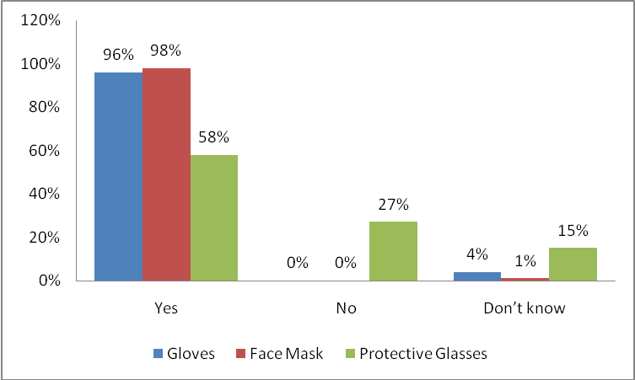
Figure 1. Patient’s attitude towards the use of different protective barriers by Orthodontist.

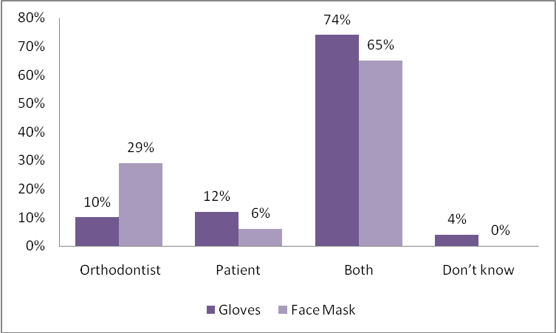
Figure 2. Patient’s opinion on whether gloves are worn to protect orthodontist or patient

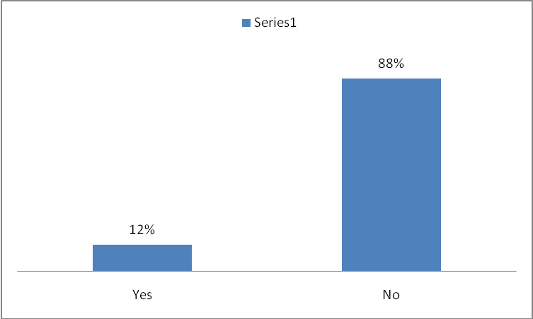
Figure 3. Patient’s opinion on whether they will go to orthodontist who doesn’t wear gloves.

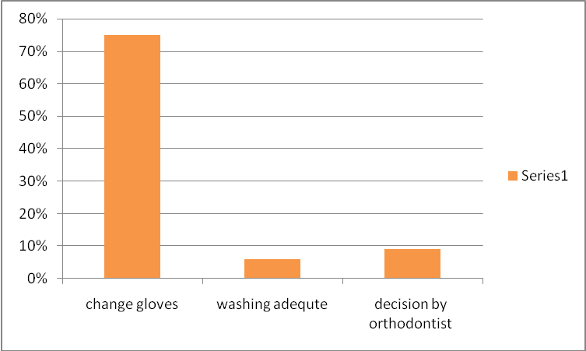
Figure 4. Patient’s opinion on whether an orthodontist should change gloves between patients or washing is sufficient.

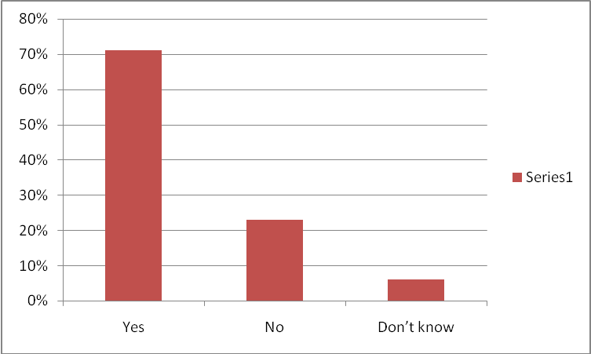
Figure 5. Patient’s opinion on whether dental assistant should wear gloves or not.

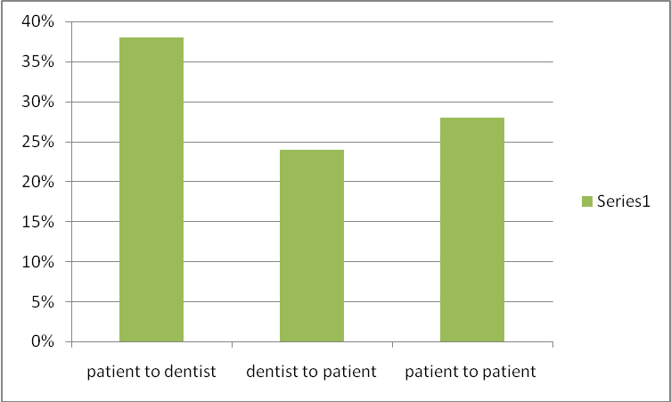
Figure 6. Knowledge regarding the purpose of wearing gloves

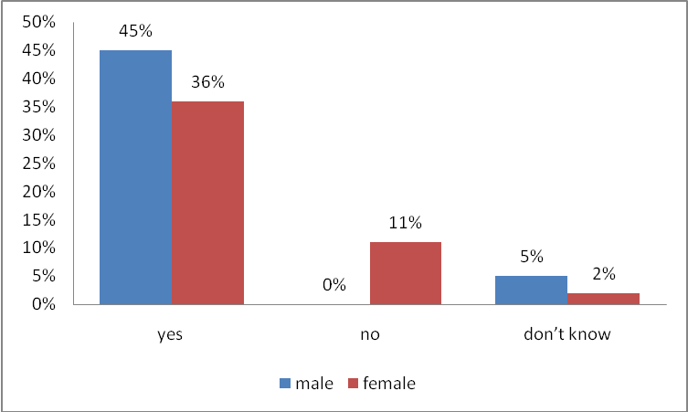
P = 0.002**, Highly significant
Figure 7. Patient’s opinion on whether or not patient is satisfied with barrier technique used by the orthodontist.

