Legends:
Fig 1: Percentage PI- Distribution by procedure
Fig 2: Percentage PI- Distribution by device

Table I³
Virus | Number of particles/ml of infected blood | Probability of  transmission
HBV  HCV  HIV | 10⁶ – 10¹³  10⁶  10 - 10³ | 1 in 3  1 in 30  1 in 300

Table II
JAW AND SIDE | ANTERIOR | POSTERIOR | TOTAL
Maxilla (24)
Right | 7 | 9 | 16
Left | 3 | 6 | 9
Mandible (15)
Right | 4 | 5 | 9
Left | 2 | 3 | 5
Total | 16 | 23 | 39

Table III
 | NUMBER (%) OF PI
TIME
Morning | 23/396 (5.80%)
Afternoon | 25/216 (11.57%)
INJURED
Operator | 40 (83.3%)
Assistant | 8 (16.6%)
DEPTH
Superficial | 46 (95.8%)
Deep | 2 (4.16%)
SITE OF INJURY
Non dominant | 45(93.75%) -30 Index finger , 15 Thumb
Dominant | 3 (6.25%)- 1 Index finger, 2 rest of the hand
PATIENT STATUS
Low risk | 42(88% )
High risk | 6(12% )
DEVICE
Contaminated | 41(85.42%)
Clean | 7 (14.29%)

Table IV
Type of procedure | No.(%) of procedures  (Total = 612) | PI  (Total = 48) | PI RATE*
Flap surgery | 146 (23.8%) | 29(60.4%) | 19.86%
Gingivectomy | 55 (8.9%) | 3 (6.25%) | 5.45%
Scaling † | 548 (89.5%) | 0 (0%) | 0%
Rootplanning/ Curettage | 122 (19.93%) | 7 (14.5%) | 5.73%
Others‡ | 64 (10.45%) | 9 (18.75%) | 14.06%
* PI = No. of PI/ No. of Procedure x 100
†Including scaling only and scaling in association with other procedure including flap surgery, gingivectomy, root planning and curettage.
‡Frenectomy, soft tissue grafting, incisional biopsy, vestibuloplasty.

Figure1
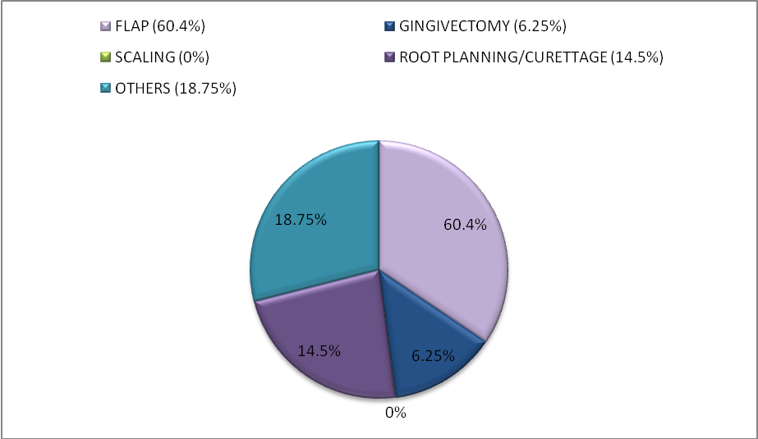

Figure 2
