Fig : 1

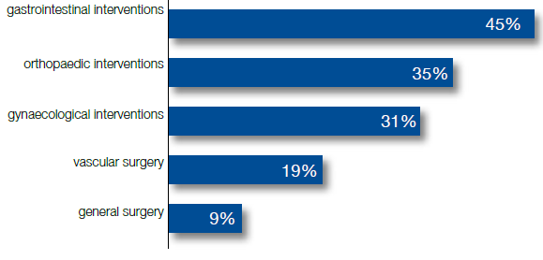

Fig : 2
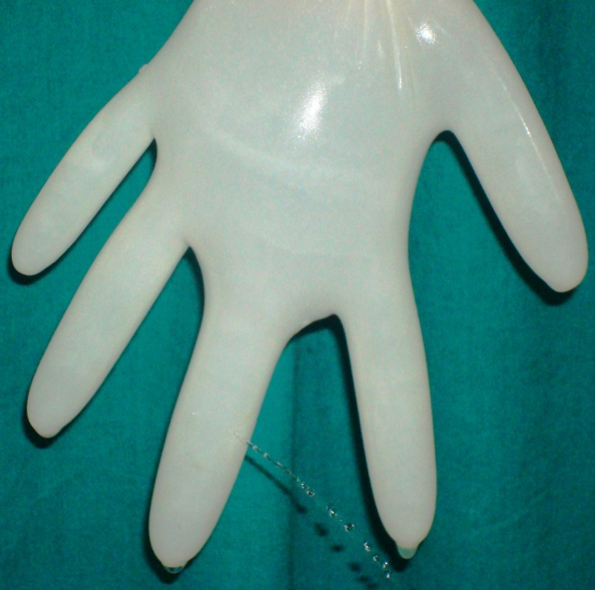

Fig : 3

Fig: 4

Fig : 5

Fig : 6

Fig : 7

*Outer GP means only outer glove perforation without inner glove being perforated.
*Inner GP denotes outer and inner both the gloves being perforated.

Fig : 8

Fig:9

*Significant exposure is the exposure which carries the potential for transmission of disease.

Blood and body fluid exposure (BBFE) protocol
Fig : 10
*Glove perforation
*SHARP INJURY
*Associated with NSI /breached surgeons hand / high risk patient
Exposure
*NOT Associated with NSI/ No breach in surgeons hand / low risk patient
Rinse wound with water and soap/ rinse mucous membrane with water

Report to supervisor, occurance variance report, Go to OHS (ER outside business hrs)

No risk
Follow up at 3 & 6 mns = hepatitis screen
Follow up 3 & 6 mns hep scan
Treatment by AIDS expert
HIV ab 3 and 6 weeks
PCR at 6 weeks
Start PEP Toxicity monitoring 72 hr, 1 wk & 2 wk, CBC, LFT, Renal function
T
Follow up at 6 mns LFT
Follow up at 6 mns HCV, LFT
6 weeks HCV ,PCR
HBIG 2 Dose if non responder
HBIG & engerix B – if not non responder

Yes
Yes
Yes
Baseline HCV , LFT
No
No
Send ‘source’ blood for NSI
Send ‘employee’ blood for NSI
Source positive

STOP no more blood test for employee
Source negative for HIV, HBV, HCV

No action
Follow up for

+ HB anti or + HB S Ag
Hepatitis B S Ag+

HC anti (.)
Hepatitis C Anti+

PCR

HIV anti (.)
HIV Anti+

PCR & CD4

Legend :
ER = Emergency room, Surgical Pavilion
OHS = Occupational Health & Safety Deptt
NSI = Needle stick injury order set in MediTech
PEP = Post exposure prophylaxis
*Proposed points as per our study in modified algorithm
No

