Chart 1 Incidence of MRSA by speciality
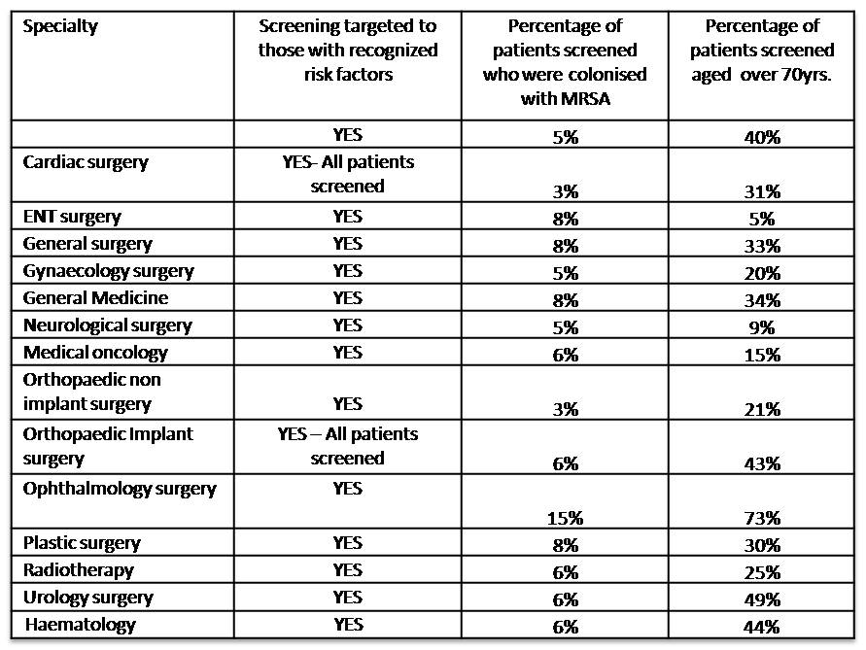

Figure 1 Number of patients colonised with MRSA by site
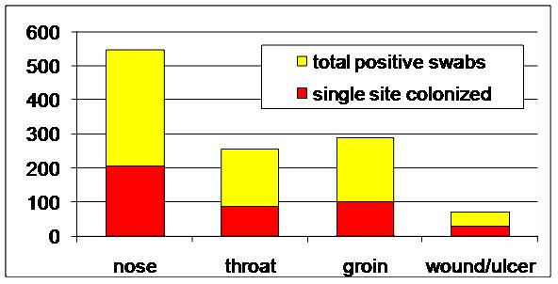
Figure 2 Risk factors for MRSA at admission
