4th July 2014
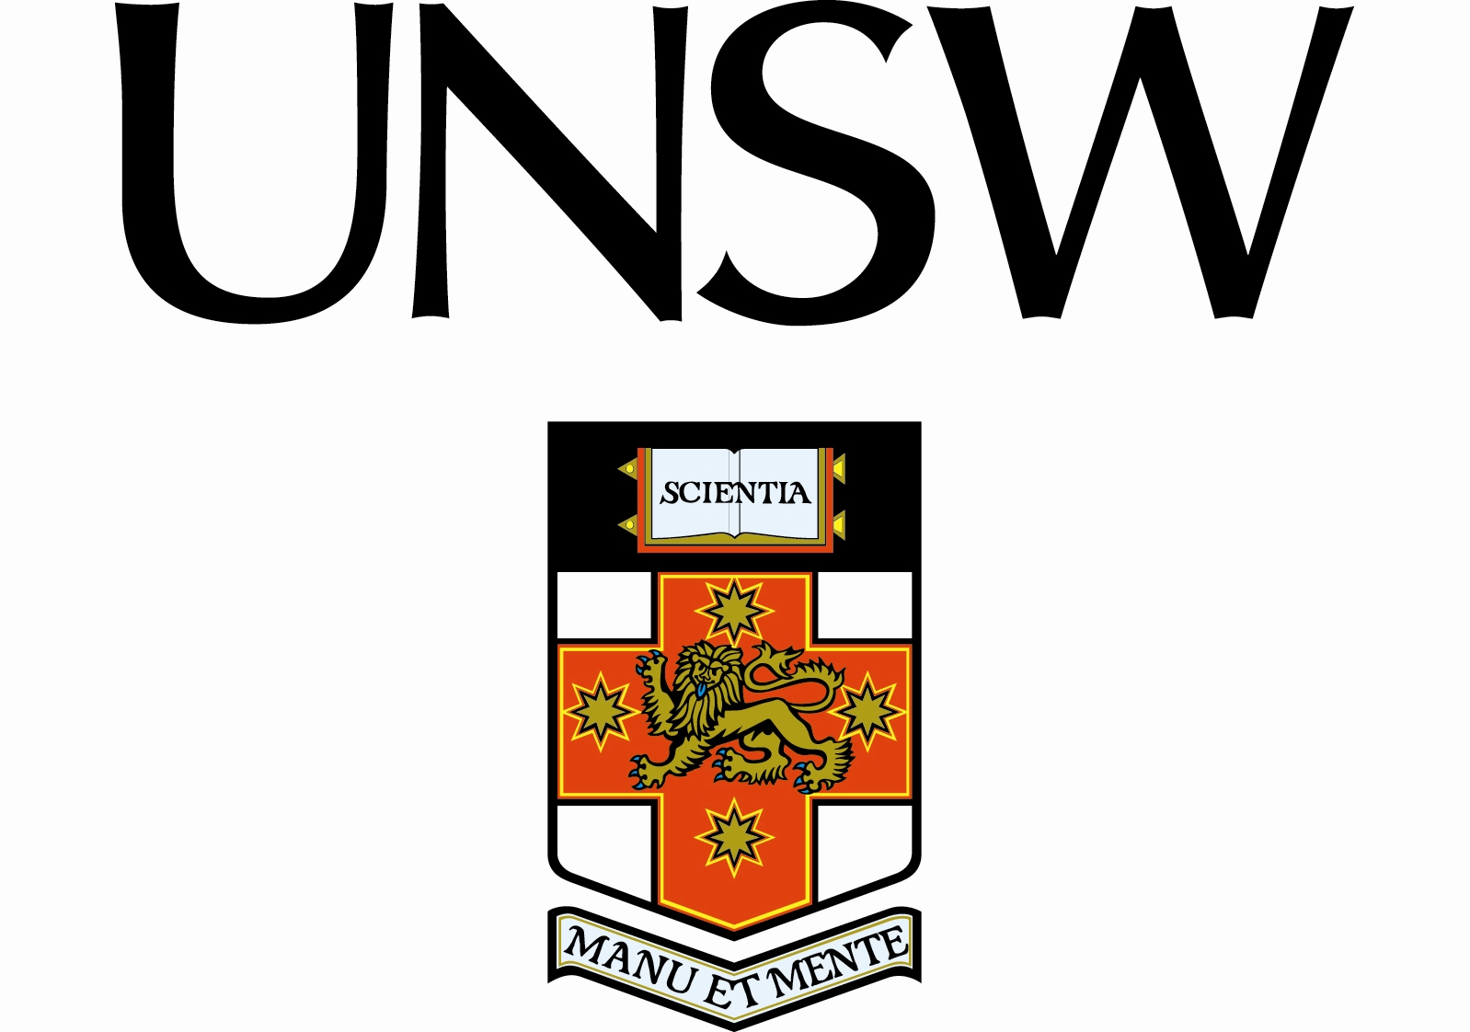

Dr Holly Seale

SENIOR LECTURER
School of Public Health
and Community Medicine

Editor in Chief
International Journal of Infection Control

To whom it may concern,

“The cookie monster muffler”: Perceptions and behaviours of hospital healthcare workers around the use of masks and respirators in the hospital setting.

Holly Seale, Jun-Sup Leem, Julie Gallard, Rajneesh Kaur, Abrar Ahmad Chughtai, Mohamed Tashani, and C. Raina MacIntyre

To ensure masks and respirators protect healthcare workers (HCWs) during respiratory virus outbreaks or a pandemic, individual, environmental, organizational and cultural issues associated with their use must be addressed. In 2012, we undertook a study which aimed to explore the current knowledge, attitudes and practices regarding the use of these products. In-depth interviews were conducted with HCWs from a major tertiary referral hospital in Sydney, Australia.

We found a broad spectrum of attitudes towards the use of masks and respirators, with many participants expressing uncertainty surrounding their use and level of effectiveness. A lack of training amongst the HCWs, uncertainty regarding hospital or health authority guidelines and the discomfort and difficulty associated with mask/respirator use, were highlighted to be the core issues resulting in poor implementation of masks and respirators in the setting. Health managers should be aware of the perceptions of HCWs toward personal protective equipment, as this is important to consider for maintaining staff confidence and work attendance during an outbreak or pandemic.

All the authors have read the current “Author Guidelines” and comply with those instructions and acceptance of the conditions posed. The authors have seen and agreed to the submitted version of the paper, that all who have been acknowledged as contributors have agreed to their inclusion, that the material is original and that it has not been neither published elsewhere nor submitted for publication simultaneously.

We hope you will consider this study for publication.

Yours sincerely,

Dr Holly Seale

School of Public Health & Community Medicine
Level 2, Samuels Building
Faculty of Medicine, University of New South Wales
Sydney, 2052, Australia
Telephone: +61 (2) 9385 3129 Fax: +61 (2) 9313 6185
Email: h.seale@unsw.edu.au

