Treatment of Healthcare Waste

– Myths and Truth in the 21st century -

Author: Jan-Gerd Kühling, Chair of Working Group Healthcare Waste (ISWA)

Keywords: Infection control, infectious waste, healthcare waste, disinfection, sterilization, decontamination, autoclave

Corresponding author: Jan-Gerd Kühling, ETLog Health EnviroTech & Logistics GmbH, Kavalierstr. 15, 13187 Berlin, Germany. e-mail: kuehling@etlog-health.de

Executive Summary
While in the past hazardous healthcare waste was generally incinerated, if it was treated at all, in the last decade more comprehensive waste management systems have been set up and alternative treatment systems have emerged. The raising of awareness about healthcare waste issues and the application of advanced systems resulted however in an increase of uncertainties and mistaken ideas.

An overview of the 7 most typical myths in modern healthcare waste treatment and the evidence-based truth on these myths are the subject of this paper. The myths to be discussed include the incineration of healthcare waste, the issue of waste “sterilization”, the myth of the need of shredding decontaminated waste, the disposal of blood, the usage of old and new autoclaves for the decontamination of waste and the centralized treatment of hazardous healthcare waste.

The existing myths and related practical problems illustrate the great need of detailed, international technical standards and norms for healthcare waste treatment equipment. They also underline the need for standardized systems for the type testing of hazardous waste treatment systems and the need for standardized tests for installed treatment systems, as well as the need for clear protocols for the regular testing of waste treatment equipment.

Introduction

In the past, the treatment of healthcare waste received only little attention, but this changed during the 80s and 90s in the western world. With the emergence of new infectious diseases and especially with the new understanding of the public health impact of the bloodborne diseases such as HIV and Hepatitis, the awareness of problems created by healthcare waste rose globally. In the last decade, countries all over the world have initiated programs to improve the healthcare waste situation (7), and several dozens of more or less successful healthcare waste projects were started (1,9).

At the same time, concerns about the by-products from the incineration process of healthcare waste (Dioxins, Furans, toxic flue ash, etc.) came up (5). Environmentally sound systems were required and developed. In the beginning, more advanced incinerators, typically equipped with several stages of flue gas treatment and on-line emission monitoring systems were set up. As the cost for the treatment of the waste in these facilities increased dramatically, a demand for alternative, more cost-efficient waste treatment systems was created – especially for the decontamination of the largest hazardous healthcare waste stream, the biohazardous waste. This demand had been answered already in the late 80s by the development of the first low-temperature, steam-based treatment systems such as autoclaves. The introduction of technical standards and testing methods for these alternative treatment plants however lagged behind in many countries. This resulted in the situation found today in several countries – that alternative treatment technologies are in use, but technical norms, standards and testing guidelines are missing (4).

The raising of awareness among waste generators regarding the risks posed by healthcare waste resulted also in uncertainty as to which types of waste were now to be considered as hazardous. As a result of the replacement of the concept of risk assessment by the precautionary principle, in several countries today huge amounts of non-risk waste are classified as hazardous waste, needing expensive treatment. The available budget for waste management in healthcare facilities is normally limited. The unnecessarily high amounts of hazardous waste designated for treatment, and the limited budgets have led to the scenario that hazardous waste is often treated by low-quality or unsafe methods (1).

Today, after more than 3 decades of experience in the treatment and management of healthcare waste, it is unfortunate that several myths and mistaken ideas can still be found in the professional healthcare waste sector. To enable the decision-maker to make a justifiable decision, rather than following rumours or instinct, these myths must be exposed. In the following discussion, seven of today’s most widely spread myths are described and evidence-based rebuttals of these myths are presented. Many more myths do however exist and so continuous efforts, training and research will be needed to eliminate the current and emerging myths and misconceptions.

Myth and Truth of Healthcare Waste Treatment

I. Incineration of Healthcare Waste

The Myth: … “Unlike a in a sterilizer, in an incinerator I can treat all types and kinds of hazardous healthcare waste“

The Truth: The term “incinerator” is used for simple, small-scale incinerators costing only several thousand dollars as well as for highly sophisticated, hazardous waste incineration plants with investment costs of up to a hundred million dollars. When speaking about incinerators, it first must be defined what kind and type of incinerator is being referred to. A typical tertiary level hospital generates today more than 50 different types of hazardous healthcare waste. No existing incinerator is able to treat all these different types of waste. While simple incinerators can treat only infectious waste, sharps and some pharmaceutical waste, more advanced incinerators are able to treat a wider range of healthcare waste, including cytotoxic materials, patho-anatomical waste and maybe solid chemicals (5). Wastes that are more difficult to treat, such liquid chemical waste, PCBs, waste contaminated with heavy metals or low-level radioactive waste, require highly specialized incinerators or chemical-physical treatment plants. Some types of hazardous waste, such as highly radioactive waste, cannot be treated even by the most sophisticated incinerators.

A problem of the more advanced, medium sized incinerators that is often overlooked are the high operation costs and the production of fly- and bottom ash. The incineration of healthcare waste in a medium-sized incinerator (with a capacity 20 to 50 kg/h), may consume from 10 to 30 litres of fuel per hour. The fuel costs alone of this type of incinerator easily reach US$300 to 400 per ton of waste. If other costs such as manpower, maintenance, financing and depreciation are added, the costs for the waste treatment double or triple. Considering the ever-present threat of again increasing fuel prices, this problem is expected to increase in future. In several countries, the bottom ash and especially the fly ash from the filter system of the incinerator are considered as hazardous waste. These additional solid wastes require solidification and costly disposal on a hazardous waste landfill (1).

II. Sterilization of Healthcare Waste

The Myth: „…Potentially infectious waste must be sterilized prior disposal as household waste“

The Truth: The term “sterilization” is mainly used in the healthcare sector to describe a process that destroys or eliminates all forms of microbial life, e.g. for the reprocessing of surgical instruments. “Sterilization” of waste can only be achieved by high-temperature incineration such that the organic material is fully combusted. The steam-based low-temperature sterilization process depends on the prior cleaning and removal or organic and inorganic materials from the items to be sterilized. Waste materials are normally not cleaned before sterilization and the organic material on the waste (the bio-burden) is not removed. Therefore the “sterilization” of the waste cannot technically be achieved as spores and other germs might be protected during the treatment process by the bio-burden.

Sterilization of potentially infectious waste however is not required at all as a reuse of the materials is not intended. Potentially infectious waste needs only to be “decontaminated” prior to disposal. Decontamination is today defined as the use of physical or chemical means to remove, inactivate, or destroy pathogens on a surface of an item to the point where they are no longer capable of transmitting infectious particles and the surface or item is rendered safe for handling and disposal (2).

Thermometric testing of the waste treatment temperature and efficiency testing by sterilization of biological indicators are today recognized by most authorities as sufficient to prove that sterilizers are able to decontaminate waste in a safe way. This means that by providing evidence that a thermal treatment plant is able to sterilize clean materials, it can be accepted as sufficient evidence that the plant can safely decontaminate potentially infectious waste.

III. Shredding of Healthcare Waste

The Myth: „ …Decontaminated healthcare waste should be shredded to reduce its volume and to ease handling and disposal“

The Truth: Due to the inhomogeneous nature of healthcare waste – ranging from very soft materials (napkins, bandages, etc.) to very hard materials (surgical steel, etc.) – the shredding of healthcare waste is a technically demanding process. This inhomogeneity of the waste requires the usage of sophisticated, industrial type shredders with investment costs of more than US$50,000 and with comparable costs for operation and maintenance. Shredding does not always ease handling and disposal. For example it does not necessarily minimize the risk of sharps accidents. Small sharp items such as needles still can be found in the waste after shredding. Sometimes shredding is found to increase the problem, as sharps that were formerly safely packed in sharps containers are released to the environment when the container is shredded.

Shredding of healthcare waste can indeed reduce the volume of the waste by up to more than 80%. However during a thermal decontamination process, the waste volume is already reduced by up to 50%. As the infectious waste from a healthcare facility represents normally less than 20% of the total waste stream, the shredding of decontaminated waste results in a total waste volume reduction of only 5-10% which is achieved at high cost. If shredding of decontaminated infectious waste is not required by the landfill operator or by existing guidelines it should be avoided. If volume reduction is needed, the compaction of the entire non-risk waste streams (household waste and decontaminated waste), instead of using a shredder, will result in an overall lower waste volume at a lower operation cost.

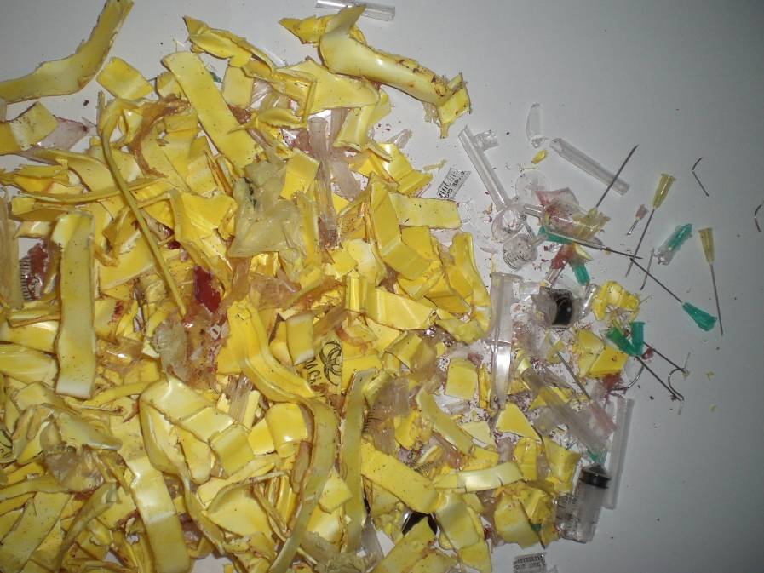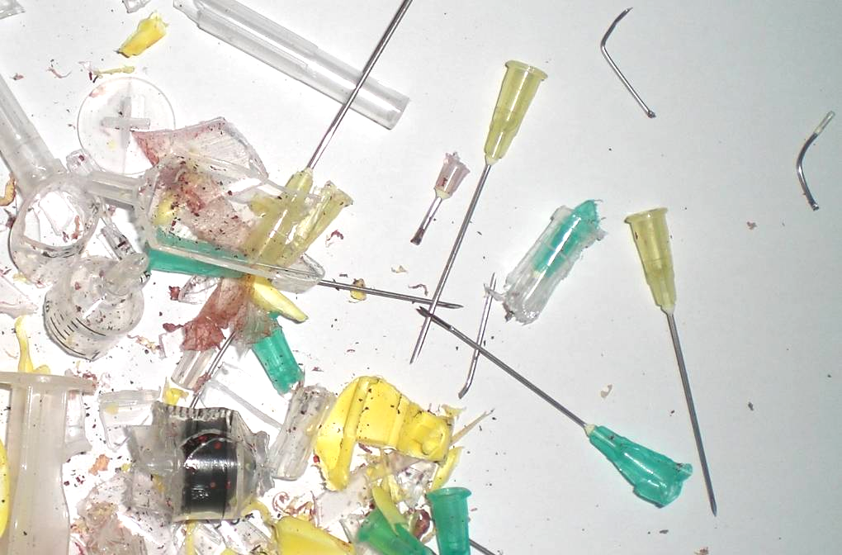
Figure 1: Sharp boxes after shredding. Needles are, if at all, only partly cut or bended.

IV. Disposal of blood

The Myth: …”Blood and other body fluids must always be treated prior to discharging and are not allowed to be disposed of in the sewerage system without prior decontamination“

The Truth: Whether or not a potentially bio-hazardous waste must be decontaminated depends on the associated risks. The level of risk can be assessed by determining the likelihood of the hazard occurring and multiplying it by the likely consequences. A risk assessment can estimate the magnitude of risk to people or the environment and is the basis for deciding whether or not the risk is tolerable. If a risk assessment is carried out for waste contaminated with blood and body fluids, having originated for example in the operating theatre, two scenarios can be developed:

1st Scenario: Disposal of liquid waste such as the contents of a suction or drainage container:
During an operation, several litres of rinsing liquids might be generated. This liquid typically contains blood which might have to be considered as biohazardous if the patient is suffering on a bloodborne infection. After the operation, this liquid is often disposed of in a sink (and so to the sewerage system), located close to the operating theatre. This scenario suggests that today, in nearly all countries, the sewerage system itself should be considered as potentially infectious.

2nd Scenario: Disposal of solid waste such as used scalpel blades or surgical needles
During an operation, disposable scalpels’ and needles are discarded and are often contaminated with blood. After an operation these items are counted, placed in a sharps container, transported to the unclean storage room, collected by the environmental services, transported to the interim waste storage place, stored, collected by the disposal company and transported for final treatment and disposal.

While in both scenarios the consequence of an infection with a bloodborne disease is similar, the likelihood of getting infected is higher in scenario 2 than in scenario 1 due to the type of waste (solid/sharp) and due to the multiple handling. Based on the principles of risk assessment, potentially infectious liquids might be therefore disposed of to the sewage system without treatment if occupational health and safety standards are considered during disposal. Potentially infectious solid items however should be separately collected, properly packed, safely transported and treated under consideration of the special risk.

This risk assessment-based way of thinking is today accepted and recommended by several institutions. For instance, the US Center of Disease Control (CDC) states that: “… No evidence indicates that bloodborne diseases have been transmitted from contact with raw or treated sewage…. therefore, the discharge of small quantities of blood and other body fluids to the sanitary sewer is considered a safe method of disposing of these waste materials.” (3).

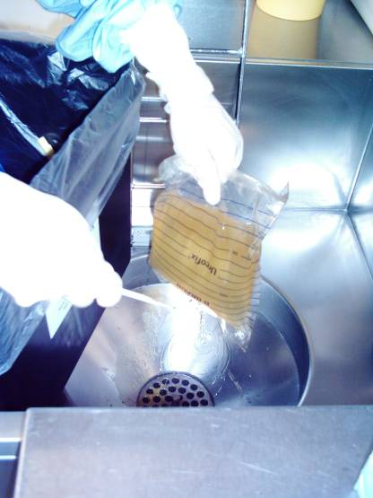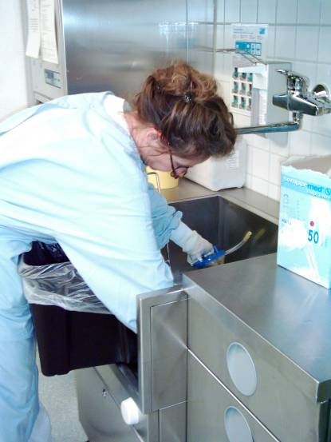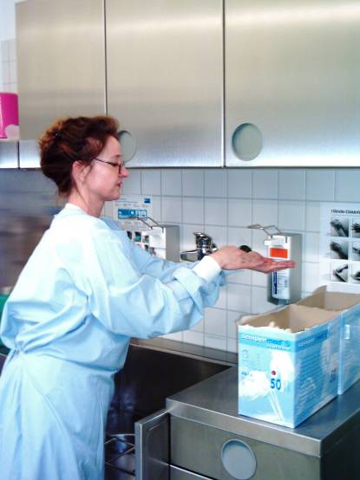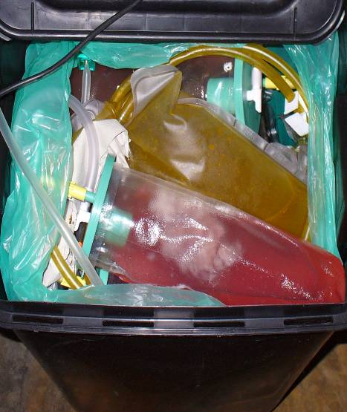
Figure 2: Nurse in a German hospital, emptying suction containers and urine bags in a sink.

V. Usage of old autoclaves

The Myth: …”Old, gravity-flow autoclaves cannot be used to decontaminate waste as they do not achieve the needed treatment temperature…”

The Truth: In 2007, the German company ETLog Health EnviroTech and Logistic GmbH carried out a research project in Vietnam, Hanoi to identify whether or not old or outdated autoclaves can be used for the treatment of biohazardous waste. For the research a used, double-jacketed and pressure controlled autoclave that was more than 20 years old was used (Type VK-75, Tyumen Plant of Medical Equipment and Tools, Russia; year of manufacture 1985). This type of downward air displacement autoclave (gravity autoclave) is used in thousands of healthcare facilities worldwide, especially in socialistand formerly socialist countries (8).

For the testing, the autoclave was filled with household waste and some liquids to simulate infectious waste. The autoclave was operated as recommended by the manufacturer. The thermometric testing showed that, in the centre of the waste bags, a maximum temperature of only about 70°C could be reached. The waste had to be considered as still infectious after treatment. In addition, gravity autoclaves release potentially contaminated air out of the treatment chamber. The research project confirmed in the first phase that the so-called myth “old type autoclaves should not be used for the treatment of biohazardous waste” is correct.
Figure 3: Test results – treatment of waste in an old, unmodified autoclave
Within the second phase of the same project however, it was shown that old autoclaves can be used for the treatment of infectious waste if they are modified. A simple add-on kit was developed which consisted mainly out of a condenser and a HEPA filter to prevent the release of pathogens to the environment during the treatment process.

Figure 4: P&I Diagram of an old autoclave (1) and with added condenser and HEPA filter(2)
In addition, the process cycle was changed and adapted to the needs of a waste treatment plant. By means of a valve ext to the gravity based air outlet of the treatment chamber (used for flushing), the pressure in the vessel was several times increased and released (to give a pulsingeffect). This “steam pulsing” resulted in an improved removal of air and a more even temperature within the waste load.

Safe decontamination of the waste was achieved at a treatment temperature of 134°C for 10 minutes. The project showed that the safe decontamination of bio-hazardous waste can be ensured even with simple, old autoclaves if the operation and treatment principles are clearly understood by the operator of the plant. A drawback however is the relatively high operational requirement relating to the control of the process cycle which was considered by most operators to be complicated. The usage of automated and validated sterilizers instead of using old sterilizers should be preferred if financially possible.

Figure 5: Recommended process cycle for the decontamination of bio-hazardous waste with a gravity type autoclave

VI. Usage of Modern Autoclaves

The Myth: ”…Modern, automated autoclaves using the fractionated vacuum-steam-vacuum cycle can treat all kinds of infectious waste…”

The Truth: Different kinds of bio-hazardous waste need different kinds of treatment processes. Today’s advanced, steam-based alternative treatment plants for the decontamination of bio-hazardous waste are automated. Such treatment, such as autoclaves with a pre-programmed fractionated vacuum-steam-vacuum treatment cycle, are tested for a certain type of waste and packing material (the so-called type-testing). The normal waste treatment program is typically designed for porous, solid waste which contains only limited amounts of liquids. If the composition of the waste is different - for example, if waste with a high liquid content is to be treated, a different treatment process is required.

In the following diagram, the different temperature curves of a typical solid waste treatment cycle are displayed. The temperature in the autoclave and the waste load with small amount of liquids (in this case container holding up to 0,1l of liquid waste) is sufficient for the treatment of bio-hazardous waste. The temperature curve in the containers with larger amounts of liquids shows however, that the liquids might not be safely decontaminated.

Therefore modern autoclaves can only treat waste which contains larger amounts of liquids if the autoclave is equipped with a special process cycle for treating liquids. In addition the operator must be trained in how to identify waste which contains larger amounts of liquids.

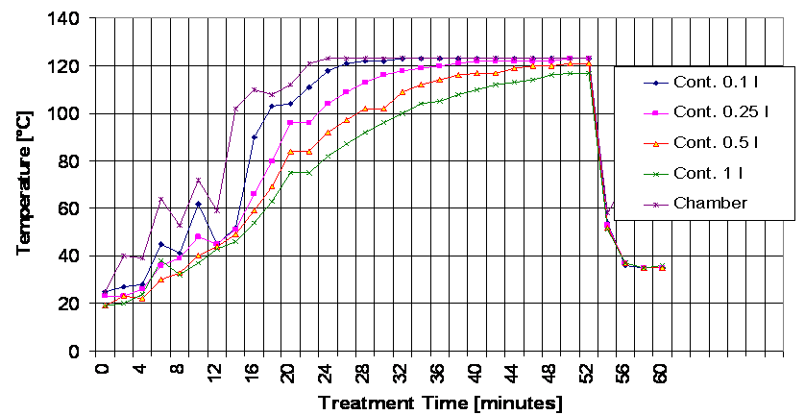
Figure 6: Actual treatment temperatures in liquids of different volumes during a typical, bio-hazardous waste treatment cycle of an advanced waste treatment autoclave.

VII. Centralized Treatment of Hazardous, Healthcare Waste

The Myth: ”…The central treatment of hazardous healthcare waste is always cheaper than on-site solutions…”

The Truth: It is correct that the higher treatment capacities of centralized treatment plants normally result in lower operation costs, when compared with on-site treatment plants. However, the centralized treatment of hazardous waste requires the transport and safe packaging of the waste to be treated. By weight and volume, bio-hazardous (infectious) waste is the largest hazardous waste stream in a healthcare facility. While solid and liquid chemical wastes often have a high density and can be stored for a longer time, the situation for bio-hazardous (infectious) waste is different.

Bio-hazardous waste typically has a low density of only about 80-120 kg/m³. This low density of the waste is associated with a large volume, increasing the logistics costs. Furthermore, bio-hazardous waste is biologically active. The storage times are therefore in most countries limited to about 2 to 3 days if the waste is not refrigerated. The high collection frequency of the waste or the need of a refrigerated storage facility add to the logistics cost.

Since the introduction of alternative treatment systems, comparable low-cost small-scale treatment systems that are easy to operate are available (4). Especially for medium or larger hospitals, the on-site treatment of bio-hazardous waste might be an interesting alternative because of the possible logistics savings. Other arguments for the on-site treatment are reduced transportation risks (the proximity principle) and reduced transport emissions.

As the treatment of other hazardous waste (e.g. pharmaceutical waste, chemical waste, cytotoxic waste, heavy metal waste, etc.) requires more complicated and cost-intensive technologies, and as these waste streams can be transported more efficiently, for these waste streams centralized treatment is likely to remain the better and more cost efficient choice.

Figure 7: Typical proportions of the main hazardous healthcare waste streams by weight and by volume.

Conclusion and Future Needs

One generation after the introduction of integrated healthcare waste management strategies and the setting up of more advanced treatment plants, several uncertainties in how to apply these strategies and treatment concepts persist. There remains great demand for more clear and efficient instructions. In the last two decades, emerging diseases such are SARS, Avian Flu, Hepatitis and HIV are increasing this demand.

Apart from bio-hazardous waste, healthcare facilities generate dozens of other types of hazardous waste. Each hazardous waste stream needs specific handling and treatment to avoid risks to staff, to the environment and to public health (7). With the exception of bio-hazardous waste and waste from the radiology department (photo-chemical waste), these hazardous waste streams are mainly produced in minor quantities. For financial reasons, these low quantities do not justify recourse to on-site treatment solutions. Comprehensive, national or regional hazardous waste treatment strategies are needed to ensure correct treatment and disposal. To enable waste generators to carry out a correct waste classification and to enable them to make decisions regarding which type of waste needs which type of treatment, the concept of risk assessment must be strengthened and capacity must be build in this sector.

Alternative, steam-based treatment systems for bio-hazardous waste might be a cost efficient solution for on-site as well as for centralized treatment. The myths and the research results that have been discussed showed that there is a strong demand for more clear technical specifications, instructions and norms. Before providing operation permits, it is recommended that a type testing of the treatment plants should be carried out in order to clearly demonstrate what type of bio-hazardous waste in what kind of packing can be treated with the specific treatment plant model and the applied treatment cycle. A protocol on the monitoring and testing after the commissioning of new treatment plants and for the regular validation of treatment plants is needed.

The successful operation of treatment plants does not depend only on the technology; it depends even more on the correct operation. Safe treatment of bio-hazardous waste is ensured only if the treatment plant operator has a clear understanding of the treatment process, the treatment requirements of the specific waste types and the application of the most suitable process cycles. As shortcomings in the knowledge of treatment plant operators can be noticed everywhere in the world, capacity building and training will be crucial for the future.

Acknowledgement
This document was first presented during the ISWA World conference in Hamburg, 2010. Parts of the manuscript were included in an article carried on the ISWA Knowledge Base website (http://www.iswa.org/en/525/knowledge_base.html)

References:
    - Y. Chartier et al (2013): Safe management of wastes from health-care activities (Second edition) WHO: http://apps.who.int/iris/bitstream/10665/85349/1/9789241548564_eng.pdf

    - Rutala WA, Weber DJ (2008): Guideline for Disinfection and Sterilization in Healthcare Facilities, CDC USA
    - CDC+HIPAC (2003): Guidelines for Environmental Infection Control in Health-Care, USA
    - Health Care without Harm Europe (2004): Non-incineration healthcare waste treatment technologies in Europe. http://www.noharm.org.
    - Batterman, S. (2004): Findings on an Assessment of Small-scale Incinerators for Health-care Waste. World Health Organization, Geneva,Switzerland.
    - Kühling J-G, Dr. Pieper U.: “Management of healthcare waste: developments in Southeast Asia in the twenty-first century”, Waste Management & Research Volume 30 Issue 9(s), September 2012
    - Kühling J-G，Schmidt T., Dr. Pieper U. (2006): “Disposal – liquid or solid? New solution for the waste stream EWC 180104”, Krankenhaus Technik + Management“ (in German)
    - Kühling J-G, Stolze, R. (2009):“Treatment of infectious waste: development and testing of an add-on set for used gravity displacement autoclaves”, Waste Management & Research Vol 27 No 4,
    - Report of the Special Rapporteur on the adverse effects of the movement and dumping of toxic and dangerous products and wastes on the enjoyment of human rights, Calin Georgescu A/HRC/18/31 http://www2.ohchr.org/english/bodies/hrcouncil/docs/18session/A-HRC-18-31_en.pdf

